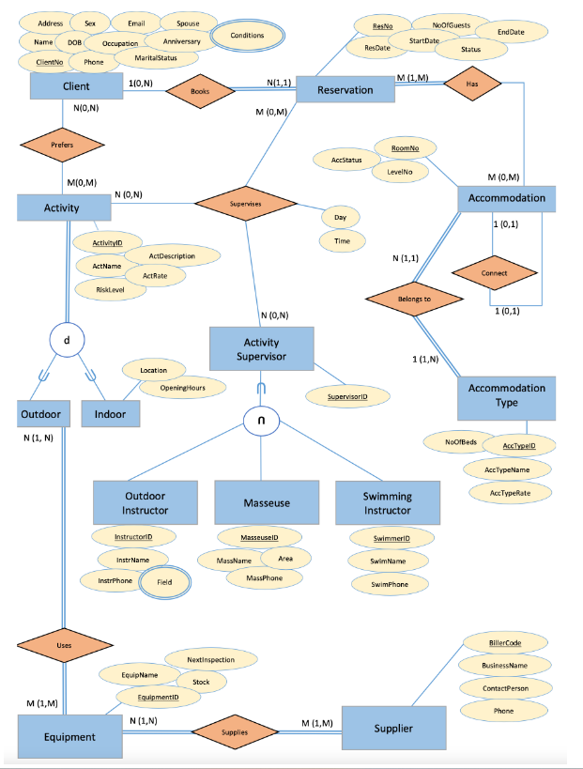Assignment 2 CSE4DBF Michael Le

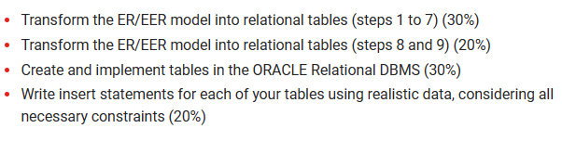

**Task 1**

**Step 1 Regular Entities, Mapping of Regular Entity Types (include superclasses)**

Client (CilentNo, Phone, Martial Status, Anniversary, Spouse, Occupation, Email, DOB, Sex, Name, Address)

Reservation (ResNo, ResDate, StartDate, NoOfGuests, Status, EndDate)

Accommodation (RoomNo, AccStatus, LevelNo)

Accommodation_Type (AccTypeID, NoOfBeds, AccTypeName, AccTypeRate)

Activity (ActivityID, AccName, RiskLevel, ActRate, ActDescription)

Outdoor_Instructor (InstructorID, instrName, instrPhone)

Masseuse (MasseuseID, MassName, Area, MassPhone)

Swimming_Instructor (SwimmerID, SwimName, SwimPhone)

Equipment (EquipmentID, EquipName, Stock, NextInspection)

Supplier (BillerCode, BusinessName, ContactPerson, Phone)

**Step 2 Weak Entries**

No Weak relationships

**Step 3 1:1 relationships**

No 1:1 Relationships

**Step 4 1: N relationships**

Reservation (ResNo, ResDate, StartDate, NoOfGuests, Status, EndDate)

Accommodation (RoomNo, AccStatus, LevelNo)

**Step 5 M: N relationship**

Has_ Accommodation (ResNo, RoomNo)

Supplies (EquipmentID, BillerCode)

Cilent_Uses (EquipmentID)

**Step 6 Multi-valued attribute**

Client (CilentNo, Conditions, Phone, Martial Status, Anniversary, Spouse, Occupation, Email, DOB, Sex, Name, Address)

Outdoor_Field (InstructorID, Field)

**Step 7 n-ary relationship (N>2)**

Supervises (ActivityID, ResNo, SupervisorID, Day, Time)

**Step 8 Specialisation/generalisation relationship**

For the purposes of outlining what each of the options mean, we present all four options (8A, B, C, and D) here. But for every specialisation, we must select ONE.

**Step 8a N relations: superclass + subclasses work for any specialisation total, partial, disjoint, overlapping.**

Activity (ActivityID, AccName, RiskLevel, ActRate, ActDescription, CilentNo, ResNo, SupervisorID)

Outdoors (ActivityID)

Indoors (ActivityID, Location, OpeningHours)

**Step 8b N relations: subclasses only (if the specialisation is overlapping)**

Outdoors (ActivityID, AccName, RiskLevel, ActRate, ActDescription, CilentNo, ResNo, SupervisorID)

Indoors (ActivityID, Location, OpeningHours, AccName, RiskLevel, ActRate, ActDescription, CilentNo, ResNo, SupervisorID)

**Step 8c 1 relation + 1 type attribute only works if (only for a specialisation whose subclasses are disjoint and has the potential for generating many NULL values if many specific attributes exist in the subclasses.)**

Activity (ActivityID, AccName, RiskLevel, ActRate, ActDescription)

**Step 8d 1 relation + N type attributes works only if (This option works for a specialisation whose subclasses are overlapping (but will also work for a disjoint specialisation))**

Activity (ActivityID, AccName, RiskLevel, ActRate, ActDescription, isOutside, isInside, Location, OpeningHours)

NOTE: isOutside and isInside are Boolean type fields

**After completing Step 8a Repeating Steps 2- 7**

**Step 2**

No Weak relationships

**Step 3**

No 1:1 Relationships

**Step 4**

No 1: N Relationships

**Step 5**

Cilent_Uses (ActivityID, EquipmentID)

**Step 6**

No Multivalued attributes

**Step 7**

Supervises (ActivityID, ResNo, SupervisorID, Day, Time, AccName, RiskLevel, ActRate, ActDescription, CilentNo)

**After completing Step 8b Repeating Steps 2- 7**

**Step 2:**

No Weak relationships

**Step 3:**

No 1:1 Relationships

**Step 4:**

No N:1 relationships

**Step 5:**

Cilent_Uses (ActivityID, EquipmentID)

**Step 6:**

No Multivalued attributes

**Step 7:**

No n-ary relationships

**After completing Step 8c Repeating Steps 2- 7**

**Step 2:**

No Weak relationships

**Step 3:**

No 1:1 Relationships

**Step 4:**

No 1: N Relationships

**Step 5:**

No M: N Relationships

**Step 6:**

No Multivalued attributes

**Step 7:**

Supervises (ActivityID, ResNo, SupervisorID, Day, Time, AccName, RiskLevel, ActRate, ActDescription, Location, OpeningHours)

**After completing Step 8d Repeating Steps 2- 7**

**Step 2:**

No Weak relationships

**Step 3:**

No 1:1 Relationships

**Step 4:**

No 1: N Relationships

**Step 5:**

No Weak relationships

**Step 6:**

No Multivalued attributes

**Step 7:**

Supervises (ActivityID, ResNo, SupervisorID, Day, Time, AccName, RiskLevel, ActRate, ActDescription, Location, OpeningHours, isOutside, isInside)

**Step 9 Category/Union Type relationship**

Activity_Supervisor (SupervisorID)

Outdoor_Instructor (InstructorID, instrName, instrPhone, SupervisorID)

Masseuse (MasseuseID, MassName, Area, MassPhone, SupervisorID)

Swimming_Instructor (SwimmerID, SwimName, SwimPhone, SupervisorID)

**After completing Step 9 Repeating Steps 2- 7**

**Step 2:**

No Weak relationships

**Step 3:**

No 1:1 Relationships

**Step 4:**

No 1: N Relationships

**Step 5:**

No M: N Relationships

**Step 6:**

Outdoor_Instructor (InstructorID, Field, instrName, instrPhone, SupervisorID)

**Step 7:**

Supervises (ActivityID, ResNo, SupervisorID, Day, Time)

**FINAL TABLES**

**NOTE:** ***foreign keys (*italicised*)* AND** PRIMARY KEYS (UNDERLINED)

Client (CilentNo, Conditions, Phone, Martial Status, Anniversary, Spouse, Occupation, Email, DOB, Sex, Name, Address) **(Step 1) (DONE)**

Reservation (RESno, RESDate, StartDate, NoOfGuests, Status, EndDate) **(Step 1) (DONE)**

Accommodation (ROOMno, AccStatus, LevelNo) **(Step 1) (DONE)**

Accommodation_Type (ACCTYPEid, NoOfBeds, AccTypeName, AccTypeRate) **(Step 1) (DONE)**

Equipment (EQUIPMENTid, EquipName, Stock, NextInspection) **(Step 1) (DONE)**

Supplier (BillerCode, BusinessName, ContactPerson, Phone) **(Step 1) (DONE)**

Has_ Accommodation (***RESno***, ***ROOMno***) **(Step 5) (DONE)**

Supplies (***EQUIPMENTid***, ***billercode***) **(Step 5) (DONE)**

Client_Cond (CILENTno, Conditions) **(Step 6) (DONE)**

Outdoor_Field (***INSTRUCTORid***, *Field*) **(Step 6) (DONE)**

Activity_table (ActivityID, ACTName, RiskLevel, ActRate, ActDescription, CilentNo, ResNo, SupervisorID) **(Step 8A) (DONE)**

Cilent_Uses (EQUIPMENTid, ACTIVITYid) **(Step 8A) (DONE)**

Indoors (ACTIVITYid, Location, OpeningHours) **(Step 8A) (DONE)**

Outdoors (ACTIVITYid) **(Step 8A) (DONE)**

Supervises (ActivityID, ResNo, SupervisorID, Day, Time, AccName, RiskLevel, ActRate, ActDescription, CilentNo) **(Step 8A) DATA MISSING**

Activity_Supervisor (SUPERVISORid) **(Step 9) (DONE)**

Masseuse (MASSEUSEid, MassName, Area, MassPhone, SUPERVISORid) **(Step 9) (DONE)**

Swimming_Instructor (SWIMMERid, SwimName, SwimPhone, SUPERVISORid) **(Step 9) (DONE)**

Outdoor_Instructor (INSTRUCTORid, Field, instrName, instrPhone, SUPERVISORid) **(Step 9) (DONE)**

**TASK 2 CREATING TABLES AND INSERTING DATA IN ORACLE APEX**

CREATE TABLE ACCOMMODATION(

ROOMno NUMBER NOT NULL,

ACCSTATUS VARCHAR2(8),

LEVELno NUMBER NOT NULL,

PRIMARY KEY(ROOMno)

);

INSERT INTO ACCOMMODATION VALUES(1,'ACTIVE',1);

CREATE TABLE ACCOMMODATION_TYPE(

ACCTYPEid VARCHAR2(7) NOT NULL,

NO_OF_BEDS NUMBER(2),

ACCTYPENAME VARCHAR2(40) NOT NULL,

ACCTYPERATE NUMBER(3) NOT NULL,

PRIMARY KEY(ACCTYPEid)

);

INSERT INTO ACCOMMODATION_TYPE VALUES('AC001',8,'deluxe accommodation',100);

CREATE TABLE ACTIVITY_SUPERVISOR(

SUPERVISORid VARCHAR2(5) NOT NULL,

PRIMARY KEY (SUPERVISORid)

);

INSERT INTO ACTIVITY_SUPERVISOR VALUES('SP001');

CREATE TABLE ACTIVITY_TABLE(

ACTIVITYID VARCHAR2(7) NOT NULL,

CILENTno NUMBER(3) NOT NULL,

RESno NUMBER(3) NOT NULL,

Supervisorid VARCHAR2(7) NOT NULL,

ACTNAME VARCHAR2(50) NOT NULL,

RISKLEVEL CHAR(1),

ACTRATE NUMBER(3),

ACTDESCRIPTION VARCHAR2(200),

PRIMARY KEY (ACTIVITYID)

);

INSERT INTO ACTIVITY_TABLE(ACTIVITYID,CILENTNO,RESNO,SUPERVISORID,ACTNAME) VALUES('AT001',1,1,'SP001','MOUNTAINEERING);

CREATE TABLE CILENT(

CILENTno NUMBER NOT NULL,

CONDITIONS varchar2(20),

FULLNAME VARCHAR2(50) NOT NULL,

PHONE VARCHAR2(13) NOT NULL,

MATRIAL_STATUS VARCHAR2(20),

ANNIVERSARY DATE,

SPOUSE VARCHAR2(50),

OCCUPATION VARCHAR2(30),

EMAIL VARCHAR2(30) NOT NULL,

DOB DATE NOT NULL,

SEX CHAR,

ADDRESS VARCHAR2(50) NOT NULL,

PRIMARY KEY(CILENTno,CONDITIONS)

);

INSERT INTO CILENT VALUES(1,'NO CONDITIONS','MICHAEL LE','0412345678','SINGLE','24-MAY-2023','NA','STUDENT','mikele0217@gmail.com','17-FEB-1998','M','NA');

CREATE TABLE CILENT_COND(

CILENTno NUMBER NOT NULL,

CONDITIONS VARCHAR2(25),

PRIMARY KEY (CILENTno,CONDITIONS)

);

INSERT INTO CILENT_COND VALUES(1,'NO CONDITIONS');

--(ONLY WORKS IN ORACLE APEX)

CREATE TABLE CILENT_USES(

EQUIPMENTid VARCHAR2(7) NOT NULL,

ACTIVITYid VARCHAR2(7) NOT NULL,

PRIMARY KEY (EQUIPMENTid,ACTIVITYid)

);

INSERT INTO CILENT_USES VALUES('EQ002','AT001');

CREATE TABLE EQUIPMENT(

EQUIPMENTid VARCHAR2(5) NOT NULL,

EQUIPNAME VARCHAR2(30) NOT NULL,

STOCK NUMBER,

NEXTINSPECTION DATE,

PRIMARY KEY(EQUIPMENTid)

);

INSERT INTO EQUIPMENT VALUES('EQ001','AT001',100,'24-JUN-2025');

--(ONLY WORKS IN ORACLE APEX)

CREATE TABLE HAS_ACCOMMODATION(

RESno NUMBER NOT NULL,

ROOMno NUMBER NOT NULL,

PRIMARY KEY(RESno,ROOMno),

FOREIGN KEY(RESno) REFERENCES RESERVATION(RESno),

FOREIGN KEY(ROOMno) REFERENCES ACCOMMODATION(ROOMno)

);

INSERT INTO HAS_ACCOMMODATION VALUES(1,1);

CREATE TABLE MASSEUSE(

MESSEUSEid VARCHAR2(7) NOT NULL,

Supervisorid VARCHAR2(7) NOT NULL,

MASSNAME VARCHAR2(30) NOT NULL,

AREA VARCHAR2(20),

MASSPHONE VARCHAR2(13) NOT NULL,

PRIMARY KEY (MESSEUSEid)

);

INSERT INTO MASSEUSE VALUES('MS001','SP001','MISTY','THAI','0495838620');

--LOCAT SHORT FOR LOCATION

CREATE TABLE INSIDE(

ACTIVITYid VARCHAR2(5) NOT NULL,

LOCAT VARCHAR2(30) NOT NULL,

OPENINGHOURS TIMESTAMP NOT NULL,

PRIMARY KEY (ACTIVITYid)

);

INSERT INTO INSIDE VALUES('AT001','Level 1 indoor swimming pool','24-JUN-2023 07:00:00');

CREATE TABLE OUTDOORS(

ACTIVITYid VARCHAR2(5) NOT NULL,

PRIMARY KEY (ACTIVITYid)

);

INSERT INTO OUTDOORS VALUES('AT001');

CREATE TABLE OUTDOOR_FIELD(

INSTRUCTORid VARCHAR2(7) NOT NULL,

Field VARCHAR2(25),

PRIMARY KEY (INSTRUCTORid,Field),

FOREIGN KEY (INSTRUCTORid) REFERENCES OUTDOOR_INSTRUCTOR(INSTRUCTORid)

);

INSERT INTO OUTDOOR_FIELD VALUES('IN001','CLIMBING');

CREATE TABLE OUTDOOR_INSTRUCTOR(

INSTRUCTORid VARCHAR2(5) NOT NULL,

Supervisorid VARCHAR2(5) NOT NULL,

instrName VARCHAR2(30) NOT NULL,

instrPhone VARCHAR2(13) NOT NULL,

Field VARCHAR2(25),

PRIMARY KEY (INSTRUCTORid)

);

INSERT INTO OUTDOOR_INSTRUCTOR VALUES('IN001','SP001','BROOK','0476952851','CLIMBING');

CREATE TABLE RESERVATION(

RESno NUMBER NOT NULL,

RESDATE DATE NOT NULL,

STARTDATE DATE NOT NULL,

NO_OF_GUESTS NUMBER(2),

STATUS VARCHAR2(10),

ENDDATE DATE NOT NULL,

PRIMARY KEY(RESno)

);

INSERT INTO RESERVATION VALUES(1,'24-JUN-2025','27-JUN-2025',10,'ACTIVE','30-JUN-2025');

CREATE TABLE SUPERVISES(

SUPERVISORid VARCHAR2(7) NOT NULL,

ACTIVITYid VARCHAR2(7) NOT NULL,

RESno NUMBER NOT NULL,

Risklevel CHAR(1),

DATE_TIME DATE NOT NULL,

DATE_DAY DATE,

ActRate NUMBER(2),

ACTName VARCHAR2(25) NOT NULL,

ActDescription VARCHAR2(100),

LOCAT VARCHAR2(30),

PRIMARY KEY (SUPERVISORid,ACTIVITYid,RESno),

FOREIGN KEY (ACTIVITYid) REFERENCES ACTIVITY_TABLE(ACTIVITYid),

FOREIGN KEY (RESno) REFERENCES RESERVATION(RESno)

);

--NOTE: LOCATION RENAME LOCAT FOR ORACLE APEX

INSERT INTO SUPERVISES VALUES('SP002','AT002',1,'H','23-MAY-2023','24-MAY-2023',99,'MOUNTAINING','Take the challenge to overcome a mountain and stand at the top to get the ultimate adventure.','NA');

CREATE TABLE SUPPLIER(

BILLERCODE NUMBER(6),

BUSINESSNAME VARCHAR2(30) NOT NULL,

CONTACTPERSON VARCHAR2(30) NOT NULL,

PHONE VARCHAR2(10) NOT NULL,

PRIMARY KEY(BILLERCODE)

);

INSERT INTO SUPPLIER VALUES(123456,'JIMS CLIMBING','JIM','0467893657');

CREATE TABLE SUPPLIES(

EQUIPMENTid VARCHAR2(5) NOT NULL,

BILLERCODE NUMBER(6) NOT NULL,

PRIMARY KEY (EQUIPMENTid,BILLERCODE),

FOREIGN KEY (EQUIPMENTid) REFERENCES EQUIPMENT(EQUIPMENTid),

FOREIGN KEY (BILLERCODE) REFERENCES SUPPLIER(BILLERCODE)

);

INSERT INTO SUPPLIES VALUES('EQ001',123456);

CREATE TABLE SWIMMING_INSTRUCTOR(

Supervisorid VARCHAR2(7) NOT NULL,

SWIMMERid VARCHAR2(7) NOT NULL,

SWIMNAME VARCHAR2(30) NOT NULL,

SWIMPHONE VARCHAR2(13) NOT NULL,

PRIMARY KEY (SWIMMERid)

);

INSERT INTO SWIMMING_INSTRUCTOR VALUES('SP002','SW0001','MISTY','0467893872');